FOCP C Programming Assignment
Module 3: Loops
Question 1: For Loop
Platform: HackerRank
Programming Language: C
Problem Link: https://www.hackerrank.com/challenges/for-loop-in-c/problem
Problem Statement
In this challenge, we learn how to use the for loop in C.
Given two integers a and b, print the appropriate output for every integer in the inclusive interval from a to b.
The following conditions must be followed:
- If the integer is between 1 and 9, print its English representation in lowercase (for example, one, two, three).
- If the integer is greater than 9 and even, print even.
- If the integer is greater than 9 and odd, print odd.
Input Format
- The first line contains an integer a.
- The second line contains an integer b.
Constraints
- 1 <= a <= b <= 1000000000
Sample Input
8
11
Sample Output
eight
nine
even
odd
Source Code
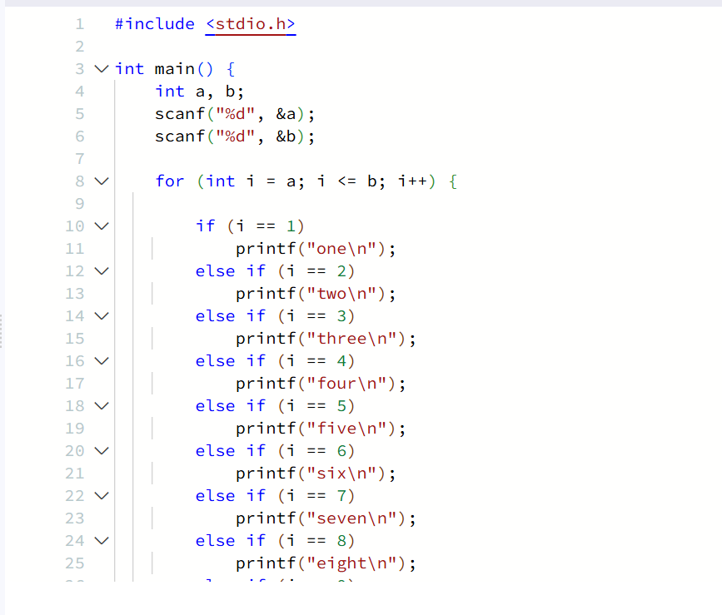
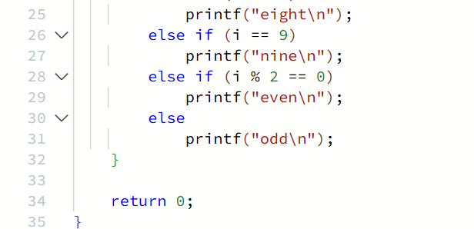Output
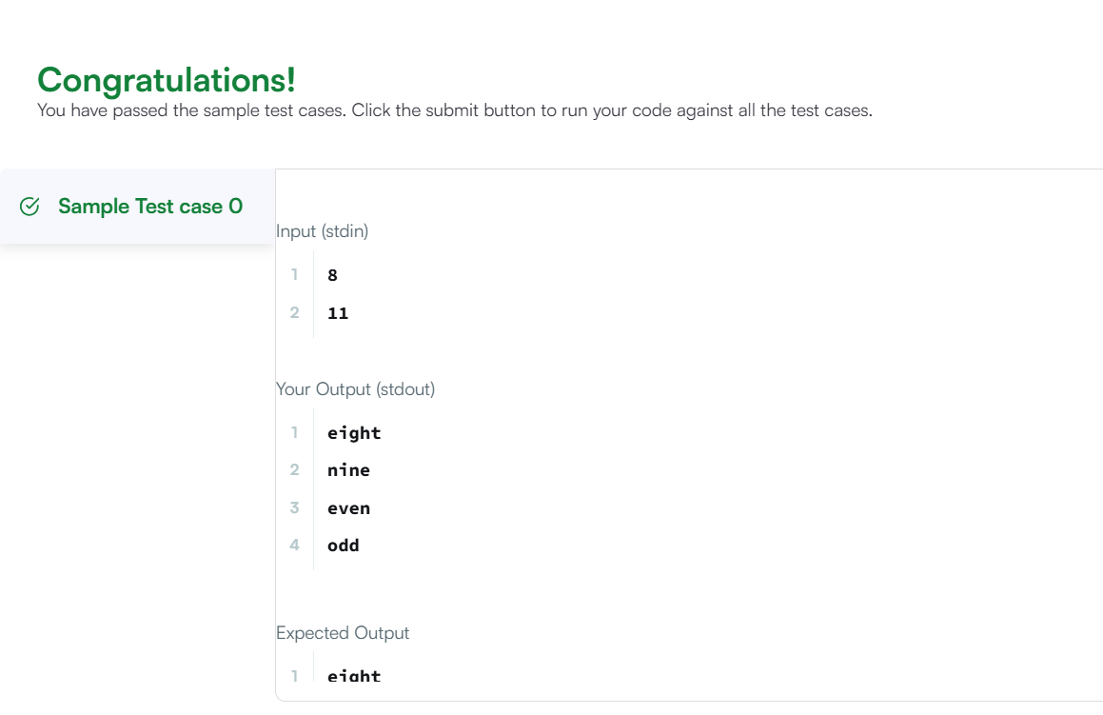
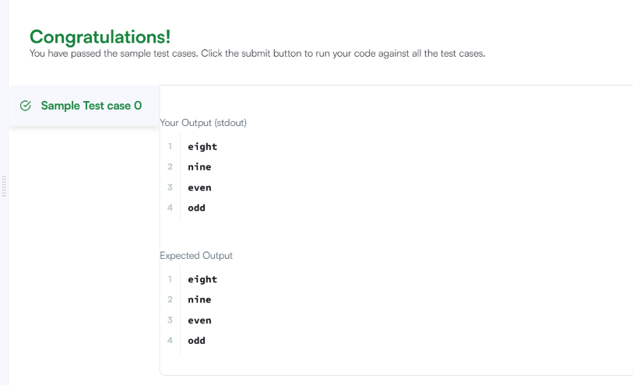Result
The program was executed successfully, and all test cases were passed on HackerRank.

